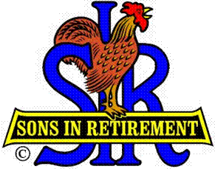
Las Trampas Branch 116
BEC Meeting Agenda
March 19, 2018

09:30 Call to order; Secretary confirm a quorum
09:31 Secretary – Fred Schafer – Approval of Feb 19 minutes
09:33 Treasurer – Jim Nickels - Report
09:37 Standing Reports
- Attendance – Kevin Donohue – Attendance, Missed Luncheon Receipts
- Membership – Phil Goff – New Members to be inducted, Guests, Visitors
- Spring Fling – Jerry Christopherson – Date and Plans, Promotion
- Activities Chair – Norm Alberts – Pickleball; Activities Survey
09:45 Big SIR Report – for Marty Katz – by Jerry Hicks
- Progress on Assistants for Activities and Support Chairs
- Committees: Chaplain – Art Donaldson; Story tellers – Pete Coggiola
09:50 Little SIR Report – Jerry Hicks
1. Seating at Luncheons
2. Speaker: Steve Moskowitz; Committee meeting
3. Ben Smith and activity reports
4. Directors: Responsibilities
5. Succession
6. RAMP chairmen
7. New member hats vs. pins; certificate holders rather than frames
10:02 Old Business
- Names and Emails request from State; Advisory
10:07 New Business:
- Dick Chaffee – SIR la Table, Reserved Seating
10:15 Other Discussion

10:20 Adjourn; Next BEC Meeting, Monday, April 16, 0930

